Experiment worksheet

2.1 Rocks have different properties

Pages 18–19 and 160

Skills Lab 2.1: Identifying rocks

What you need

• Rock samples (unnamed, perhaps labelled A, B, C, D etc.)

• Hand lens

• Table 1

What to do

1 Examine each rock sample with the hand lens and use the key in Table 1 to identify it. Be aware of the following.

• Crystals in rocks have straight edges and flat, shiny surfaces.

• Grains are not shiny, they are jagged or rounded and more like grains of sand.

• Coarse grains are about the size of a grain of rice, medium grains are smaller but still visible to the naked eye and small grains are only visible with a hand lens or magnifier.

2 Display your results in a table that identifies the rock sample (e.g. sample A), lists its main properties and gives its name.

|  |
| --- |
|  |

Questions

1 How difficult was it to identify your rock samples?

2 Were there any samples you could not identify?

3 Compare your results with those of another group. Were there any differences between your results?

4 Ask your teacher for the names of your rock samples and see which ones you got right (hopefully all of them).

**TABLE 1** Key for common types of rocks

|  |  |  |
| --- | --- | --- |
| 1 | Does the rock have layers? (Use a magnifying glass to check) | Yes – Go to 3; No – Go to 2 |
| 2 | Can you see cracks in the rock? | Yes – Go to 4; No – Go to 5 |
| 3 | Can sand be rubbed off the rock? | Yes – **Sandstone**; No – Go to 8 |
| 4 | Is the rock a light colour (i.e. mostly white)? | Yes – **Marble**; No – Go to 10 |
| 5 | Does the rock look like glass? | Yes – **Obsidian**; No – Go to 6 |
| 6 | Does the rock have a lot of holes that make it light to hold? | Yes – **Pumice**; No – Go to 7 |
| 7 | Is the rock grey to black? | Yes – **Basalt**; No – **Limestone** |
| 8 | Can you see crystals in the rock? | Yes – **Gneiss**; No – Go to 9 |
| 9 | Can you easily split the rock into thin, flat pieces? | Yes – **Slate**; No – **Shale** |
| 10 | Does the rock have a lot of holes that make it light to hold? | Yes – **Pumice**; No – **Granite** |

Experiment worksheet

2.2 Rocks are made up of minerals

Pages 20–21 and 160

Skills Lab 2.2: Testing the hardness of common substances

What you need

• 5 cm long iron nail for scratching tool

• Samples of:

• Glass microscope slide

• Disposable plastic Petri dish

• 2 cm × 5 cm piece of copper sheet

• Half a stick of chalk

What to do

1 Scratch the objects against each other and rank them from softest to hardest. When testing the hardness, scratch only a small part of the mineral or object. A 5 cm long scratch is all that is needed.

Which sample is the hardest?

Which sample is the softest?

2 Collect some mineral samples. Arrange them in order of hardness. Minerals such as feldspar, quartz and calcite are listed in Table 1.

Questions

1 Did your results match the results of other groups? Use examples as evidence to support your answer.

2 Explain the phrase, ‘Hardness of a rock is a relative measurement’.

**TABLE 1** The Mohs scale of mineral hardness. Every mineral will scratch the minerals above it.

| HARDNESS | MINERAL |
| --- | --- |
| 1 | Talc |
| 2 | Gypsum |
| 3 | Calcite |
| 4 | Fluorite |
| 5 | Apatite |
| 6 | Feldspar |
| 7 | Quartz |
| 8 | Topaz |
| 9 | Corundum |
| 10 | Diamond |

Experiment worksheet

2.3 Minerals are a valuable resource

Pages 22–23 and 161

Experiment 2.3: Testing the minerals in toothpaste

Aim

To determine which brands of toothpaste, and which minerals, are most effective in removing a stain from porcelain tiles.

Materials

• 3 porcelain tiles

• Toothbrush

• Water

• Permanent marker

• Toothpaste (at least three brands)

Method

1 Record the list of ingredients in the toothpaste.

2 Use the permanent marker to mark a cross in the centre of each porcelain tile.

3 Put a pea-sized amount of toothpaste on the toothbrush. Brush one of the marked tiles 50 times in one direction. Try to use the same force with each stroke.

4 Record how many strokes it took to remove the mark from the tile.

5 Use the water to rinse off the toothbrush thoroughly.

6 Repeat this measurement three times.

Inquiry: What if another toothpaste, with different minerals, was used to remove a stain?

Write a hypothesis for your question.

What (independent) variable will you change from the first method?

What (dependent) variable will you measure/observe?

Name three variables you will keep the same/control.

Use the method you followed previously to test the various toothpastes.

Results

Complete Table 1 to show the number of strokes required to clean the tile.

TABLE 1

|  |  |  |  |  |  |  |
| --- | --- | --- | --- | --- | --- | --- |
| Toothpaste brand | Minerals present | Number of strokes required | | | | Observations |
| Attempt 1 | Attempt 2 | Attempt 3 | Average |
|  |  |  |  |  |  |  |
|  |  |  |  |  |  |  |
|  |  |  |  |  |  |  |
|  |  |  |  |  |  |  |
|  |  |  |  |  |  |  |

Discussion

1 Why did you repeat each measurement three times?

2 Which brand of toothpaste was most effective in cleaning the mark off the tiles?

3 Many false teeth are made of porcelain. What recommendations would you make to a person with teeth of this type?

4 What role does fluoride play in toothpaste?

5 Excess fluoride ingestion causes fluorosis – a condition in which developing teeth become discoloured. Describe how young children may be vulnerable to this condition.

Conclusion

Describe the role of each of the following minerals in toothpaste.

Fluorite

Mica

Sand/silica

Sodium carbonate

Experiment worksheet

2.4 Igneous rocks develop from magma and lava

Pages 24–25 and 162

Experiment 2.4: What affects crystal size?

Aim

To grow crystals and determine what affects their size.

Materials

• Alum solution

• Bunsen burner

• Matches

• Heatproof mat

• Tripod

• Gauze mat

• 2 Petri dishes

• Evaporating dish

• Safety glasses

• 250 mL beaker

• Tablespoon

Method

1 Prepare a solution of alum by mixing 2½ tablespoons of alum with ½ cup of hot water. Stir until the alum is dissolved.

2 Pour roughly equal amounts of alum solution into the evaporating dish and the two Petri dishes.

3 Put one of the Petri dishes in the refrigerator.

4 Put the other Petri dish on a window sill.

5 Place the evaporating dish on the gauze mat.

6 While wearing safety glasses, gently heat the evaporating dish containing the alum solution over a yellow (safety) flame. The yellow flame is cooler and will allow for gentle boiling.

7 Continue heating the solution until nearly all the water has evaporated.

8 Observe the size of the crystals formed in the evaporating dish.

9 After 2 days, observe the size of the crystals formed in the two Petri dishes.

10 Observe the crystals formed in the refrigerator again after 4 or 5 days.

Results

In the space provided, draw a labelled diagram of the crystals formed in the evaporating dish and in the two Petri dishes. Your diagram needs to show the different sizes of the crystals in the different dishes.

|  |
| --- |
|  |

Discussion

1 What was the independent variable for this experiment?

2 What was the dependent variable?

3 Name three variables you needed to control.

4 Each of these crystals grew over a different time span. How does the time allowed for the crystal to form affect the size of the crystals?

Conclusion

What do you know about the factors affecting crystal size?

Experiment worksheet

2.5 Sedimentary rocks are compacted sediments

Pages 26–27 and 163

Experiment 2.5: Making sedimentary rocks

Aim

To make small samples of sedimentary rocks and compare them against real samples.

Materials

• Dry clay

• Dry sand

• Plaster of Paris

• Small, smooth pebbles

• Samples of sedimentary rocks

• Water

• Mortar and pestle

• Teaspoon

• Four empty matchboxes

• White tile

Method

1 Grind a lump of dry clay with a mortar and pestle until it is fine and powdery.

2 Using the teaspoon, mix the dry ingredients for each rock sample on a white tile according to the recipes in Table 1, but don’t add the water just yet. You will need to prepare two shale samples to use in Experiment 2.6.

3 Pile up your ingredients into a little hill and make a small dip in the centre for the water.

4 Slowly add the water and stir until the ingredients are uniformly mixed. Be careful not to make the mixture too wet.

5 Press your mixture into an empty matchbox, label it with the rock type and your name and leave it to dry for 2 days.

6 When your ‘rock’ is dry, peel off the matchbox and examine your sample. Take digital photos of your samples and photos of the ‘real’ rocks for comparison. Keep your two shale samples for Experiment 2.6.

**TABLE 1**

|  |  |  |  |  |  |
| --- | --- | --- | --- | --- | --- |
| Rock | Number of teaspoons | | | | |
| Dry clay | Sand | Plaster of Paris | Pebbles | Water |
| Sandstone | ½ | 4 | ½ | 0 | 2 |
| Shale | 5 | ½ | 0 | 0 | 2 |
| Conglomerate | ½ | 1 | ½ | 4 | 2 |

Results

Include images of your rocks in the space provided, along with any statements about the process or products.

|  |
| --- |
|  |

Discussion

1 In what ways were your rocks similar to real sedimentary rocks?

2 What were the differences between your samples and the real rocks?

Conclusion

What have you discovered about sedimentary rocks?

Experiment worksheet

2.6 Metamorphic rocks require heat and pressure

Pages 28–29 and 164

Experiment 2.6: Making a metamorphic rock

Aim

To make a sample of a metamorphic rock.

Materials

• 2 shale rock samples from Experiment 2.5

• Bunsen burner

• Tripod

• Pipe clay triangle

• Gauze mat

• Evaporating dish

• Tongs

• 2 × 250 mL beakers

Method

1 Allow your shale samples to dry for approximately 1 week.

2 Place one of the shale samples on a pipeclay triangle on top of a gauze mat and heat strongly over a blue Bunsen burner flame for about half an hour. You could place an evaporating dish upside down over the shale to retain more heat.

4 After about 30 minutes of heating, allow the sample to cool for 10 minutes. Then, use the tongs to carefully pick up the shale sample and drop it into a beaker of water.

5 Drop the second, unheated shale sample into another beaker of water and observe what happens to the two rock samples.

Results

Record your observations in a table using the space provided.

|  |
| --- |
|  |

Discussion

1 What differences do you notice about the two rock samples when they are dropped into the water?

2 Can strong heat change the properties of rocks over time?

3 How different was your new metamorphic rock sample from the original shale sample? Was the method successful?

Conclusion

What do you know about the formation of metamorphic rocks?

Experiment worksheet

2.7 The rock cycle causes rocks to be re-formed

Pages 30–31 and 165

Skills lab 2.7: Modelling the rock cycle

What you need

• Crayons

• Sharpener

• 2 sheets of

• Aluminium foil

• 2 wooden blocks

• Beaker

• Bunsen burner

• Large clamp

• Tripod

• Gauze mat

• Stirring rod

• Matches

What to do

1 Remove the paper from the crayons.

2 Shave the crayons into small piles. Keep each colour in a separate pile.

3 Cover one wooden block with aluminium foil.

4 Sprinkle a layer of crayon shavings over the aluminium foil to form the first layer.

5 Repeat step 4 for the remaining colours of crayons.

6 Cover the layers of crayons with another sheet of aluminium foil.

7 Place the second wooden block on top of the foil and press down with as much pressure as possible.

8 Remove the top block and aluminium foil and examine the compacted shavings.

9 Place the shavings between the aluminium foil and wooden blocks again.

10 Apply the large clamp around the wooden blocks and shavings. Tighten the clamp as much as possible.

11 Remove the clamp and examine the compacted crayon shavings.

12 Place the compacted crayon shavings into the beaker.

13 Heat the compacted crayon shavings over the Bunsen burner, stirring occasionally.

14 Allow the crayon mixture to cool.

15 Examine the resulting crayon sample.

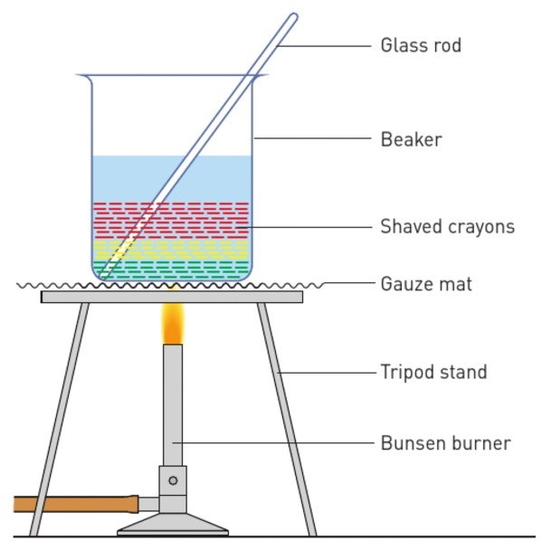

Figure 1 Experimental setup

Questions

1 What type of weathering (mechanical or chemical) took place at step 2?

2 What term is used to describe the movement of the sediment pile of crayon shavings onto the aluminium foil at step 4?

3 What type of rock did you form in step 8?

4 What type of rock did you form in step 11?

5 What type of rock did you form in step 15?

6 What are the similarities and differences between the three forms of rock you created?

Experiment worksheet

2.8 Weathering and erosion can be prevented

Pages 32–33 and 166

Challenge 2.8: Preventing soil erosion

Design brief

Design a way to prevent a 5 cm layer of soil in a large foil lasagne dish from being eroded when water is poured from a watering can. The lasagne dish should be set at an angle.

Criteria restrictions

• Pebbles can be no larger than 1.5 cm in diameter.

• Sticks must be less than 5 cm long.

• Artificial materials must not be toxic to the environment.

• No more than 1 cup of material may be added.

• A maximum amount of soil must still be available for cultivation.

Questioning and predicting

• How will you prevent the soil from being washed away?

• What materials will you use?

• Where will you position the materials on the lasagne tray?

• Figure 1 shows the general setup of the experiment.

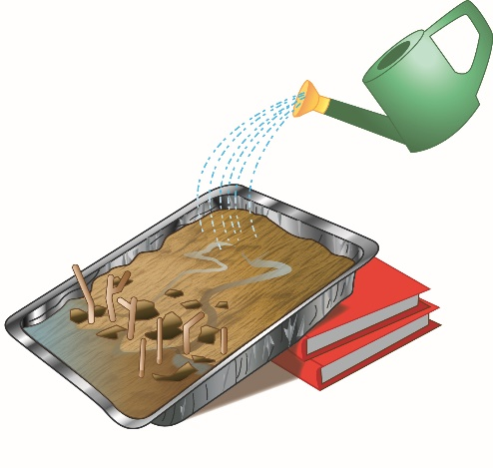

Figure 1 Experimental set-up

Processing, analysing and evaluating

1 What changes did you have to make to your design to ensure that it was stable?

2 What was the most successful feature of your design?

3 What were the limitations of your design?

4 Would it be possible to create a large-scale version of your design? Explain how your materials correlate to materials used in the large-scale version.

5 If you were doing this experiment again, explain how you would modify your design.

Communicating

Present the various stages of your investigation in a formal experimental report.

Experiment worksheet

2.9 Rocks are studied by geologists

Pages 34–353 and 166

Challenge 2.9A: Using evidence to deduce

Scale and measurement

The only evidence of a dinosaur stampede is near Winton in Queensland. A large theropod, which took steps of up to 2 m in length and walked at 9 km/h, approached from the north. After six steps the animal slowed down and, at the tenth step, it turned right. The smaller tracks show that there was then a stampede by 150 smaller ornithopods and coelurosaurs.

1 How would palaeontologists know the species of the dinosaurs involved in the stampede?

2 What information would help palaeontologists work out the weight of the dinosaurs?

3 How could the palaeontologists determine how fast the dinosaurs were travelling?

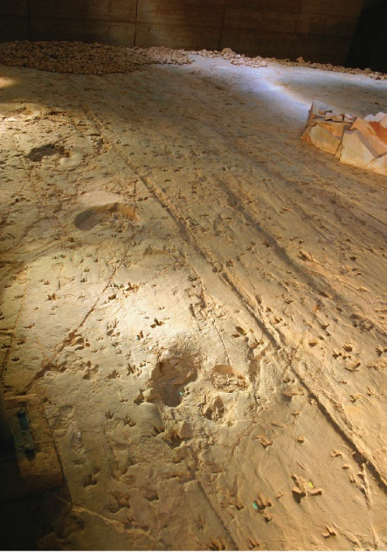4 How could the palaeontologists tell that the theropod slowed down?

5 Propose a reason for the stampede.

**FIGURE 1** These footprints from near Winton, in Queensland, show a dinosaur stampede.

Experiment worksheet

2.9 Rocks are studied by geologists

Pages 34–35 and 167

Challenge 2.9B: Reconstructing animals

What you need

• Figures 1–3 for photocopying

• Scissors

• Glue

• Tracing paper

What to do

1 Figure 1 shows pieces of a human skeleton, with some bones held together and some separated. Each bone is shown in front view. You'll also find a printable version in your obook. Photocopy and cut out the bones and glue them into your notebook in the shape of a person. (Enlarge the photocopy if you need to.) Then, draw the skin, leaving space for organs and muscles. Use your own body to work out the right and left arms and legs.

2 Figure 2 shows the bones of a frog, with some bones held together and some separated. Each bone is shown in top view. Photocopy and cut out the bones and glue them into your notebook in the shape of a frog. (Enlarge the photocopy if you need to.) Then, draw the skin, leaving space for organs and muscles. The arms and legs are the most difficult.

3 Figure 3 shows the broken skeleton of an extinct amphibian found as a fossil in Queensland. Each bone is shown in top view. Photocopy and cut out the bones and glue them into your notebook in the shape that you believe this animal may have had in real life. (Enlarge the photocopy if you need to.) Then, draw the skin, allowing for organs and muscles. Colour the animal and draw in some of its habitat.

Discussion

1 What assumptions have you made about the size of the human muscles in Figure 1?

2 How did you decide the positions of the frog bones in Figure 2? Did you refer to a picture of a modern day frog? Is this a valid method to use?

3 What assumptions have you made about the colours of the amphibian’s skin in Figure 3? Explain the reasons for your choices.

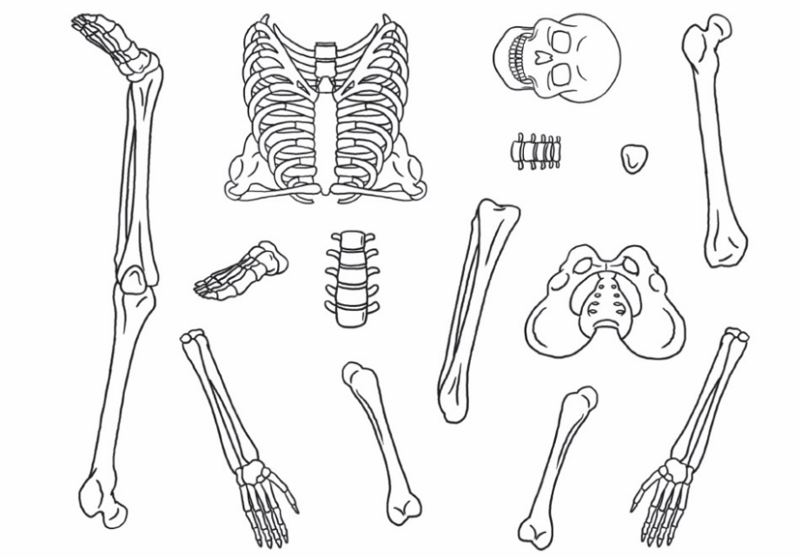

FIGURE 1

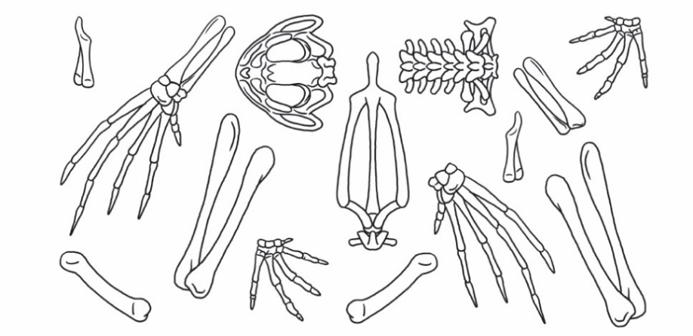

FIGURE 2

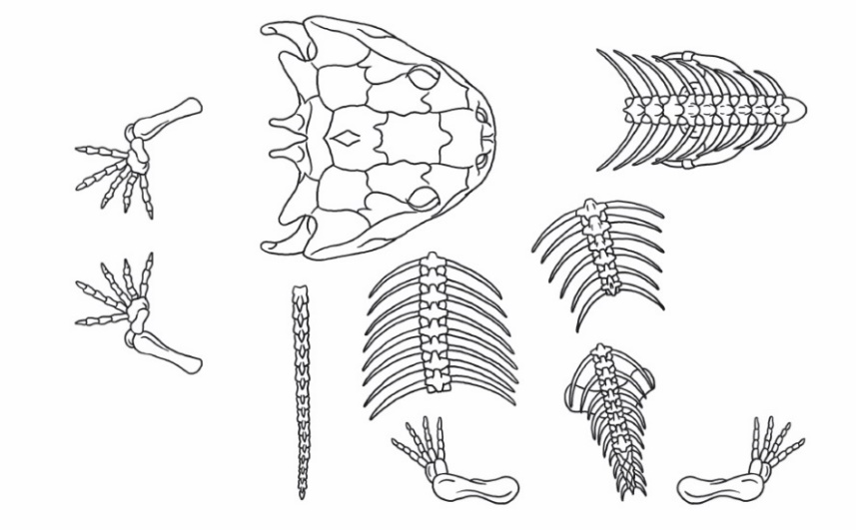

FIGURE 3